Gout and Other Crystal Arthopathies 1
Scleroderma, Dermatomyositis and Polymyositis 14
Rheumatoid Arthritis 25
SLE 40
Osteoarthritis and Imaging 58
Giant Cell Arteritis, Polymyalgia Rheumatica, Fibromyalgia 72
Spondyloarthropathies and Psoriatic Arthritis 84
Lecture 118: Rheumatology Revision 98

Gout and Other Crystal Arthopathies

Crystals Found in Synovial Fluid
- Monosodium urate monohydrate = acute gout, tophaceous gout
- Calcium pyrophosphate dehydrate = spectrum, acute pseudogout, destructive arthropathy, asymptomatic
- Basic calcium phosphate = Milwaukee shoulder
- Calcium oxalate = acute arthritis
- Lipid = acute arthritis
Gout
- Increased production (10%)/ intake vs decreased clearance (90%)
- Production: genetic due to PrPP synthetase mutation, acquired due to myeloprolif, high intake, alcohol, obesity, high trigs. 1/3 from diet, 2/3 endogenous
  - Urate produced from purines (dietary = red meat, seafood, bacon, dairy and coffee protective, alcohol = beer>wine>spirits, endogenous), oestrogen reduces hyperuricaemia therefore less incidence in females cf males, transplant (tacro and cyclosporine are risk factors)
- Reduced Excretion 90%: genetic due to HRPT mutation, renal disease, HTN, drugs (ASA, diuretics, cyclosporine)
  - Urate excreted from kidneys
- Pathogenesis of clinical gout due to urate crystal supersaturation [note in 49% hyperuricaemia absent] + nucleating factors (seed from fragment of cartilage, debris) + favourable factors (decr pH, cold, decreased hydration of cartilage) crystalisation activation of inflamasome IL-1 beta secretion phagocyte recruitment, inflammation, cytokines IL6, TNF-alpha
- Acute gout natural Hx self termination in majority, because blood and oedema incr pH, incr temp, decreases crystal formation; monoarticular mainly intercritical period for weeks/ months [ongoing damage can occur] complicated gout with longer duration, polyarticular in features chronic tophaceous destructive gout [transitions to this when inter-critical periods no longer pain free
- Radiology
  - Swelling, eccentric opacities, well preserved joint space, punched out erosions with sclerotic margins and overhanging edges
  - Dual energy CT diff CPPD from urate, research tool, good in inaccessible joints

- Dx:
  - Hx/ Ex/ get aspirate negative bifringement crystals, rod and needle shaped
- Rx acute gout
  - NSAIDs: need dose upper limit of normal, normal CIs for NSAIDS exist
  - Colchicine: disrupts microtubule fx low dose = high dose with less SE, use in acute situation, long term SE = neuromyopathy in renal impairment
  - Systemic corticosteroid = need 30 – 50mg for 5d, other option = depot ACTH (40mg IM)
  - Intra-articular corticosteroid = req technical competence, skin atrophy at site of inj, rapid onset of action, well tolerated
  - Canakinumab (IL-1β) in an RCT, good evidence coming, licensed in EU
  - Anakinra: IL-1R antagonist, shorter half life than canakinumab
- Rx tophaceous gout
  - Symptom control/suppression – colchicine can be used 0.5mg daily, EMG/ NCS mild axonopathy, myoneuropathy risk, low dose oral corticosteroids, IL-1 inhibition
  - Reduce urate load, aim <0.36mM: Indication for Rx with hyperuricaemia + gouty arthritis (tophi, erosions, >2 attacks/yr, urate nephropathy, urate calculi), NOT Rx if asymptomatic and non of the aforementioned as toxicity to great and evidence of benefit lacking
  - Allopurinol inhibits xanthine oxidase, start low, dose 100 – 800mg. NOT TO BE USED WITH AZATHIOPRINE, renally excreted, risk of hypersensitivity [HLAB58, occurs <6w into dose significant DRESS (Drug rash with eosinophilia and systemic symptoms + interstitial nephritis + hepatitis)
  - Feboxistat, now licensed, non purine analogue inhibitor of xanthine oxidase allopurinol allergy pts
  - Uricosouric agents effectively inhibit uric acid reabsorption in prox tubule [URAT1/ OAT4 inhibition] eg probenecid + losartan
Calcium Pyrophosphate Dihydrate Arthropathy
- Very poorly understood pathophysiology therefore will not discuss further, crystal shedding and activation of inflammasome from cartilage is thought to be fundamental
- Risk factors:
  - Age, female, metabolic [hypophosphataemia, hypomagnesaemia, hyperparathyroidism, OA, haemochromatosis, wilsons disease]
- Presentation
  - Most likely cause of asymptomatic chondrocalcinosis, other presentations include acute monoarthritis, esp knee, wrist, ankle, shoulder, suspect if elderly and female (gout = male more common), effusions are typically bloody with weakly positive bifringement crystals
- Dx
  - Effusion positive bifringement crystals (weakly), rhomboid shape, may miss
  - Radiology = chondrocalcinosis, esp meniscus
- Rx
  - Joint aspirate, immobilization, NSAIDS, intra-articular and systemic steroids
Basic Calcium Phosphate Hydroxyapatite (BCP)
- Large joint destructive arthopathy aka Milwaukee shoulder = massive blood stained effusion

Scleroderma, Dermatomyositis and Polymyositis

Epidemiology of Myositis (key points)
- Rare – incidence 5-10 cases/million, female > male, bimodal incidence peaks child 5 – 15yo (child disease burns out but left with extensive tissue calcification) + adult mid life (30 – 50y)
Dermatomyositis
- Proximal muscle weakness and/or pain
- Skin rash = heliotrope rash, shawl sign, gottron’s papules [pathomnemoni, erythematous rash over MCP and PIPJ], dilated nailfold capillaries, mechanics hands, interstitial lung disease
- Dx: and Ix
  - Suspect based on clinical Hx
  - CK, aldolase but maybe normal
  - ANA+, ENA Jo1 = tRNA synthetase Abs (more for polymyositis but occurs in Dermatomyositis), Mi-2 (highly specific), TIF-1-gamma Dermatomyositis + malignancy
  - EMG myopathic features (increased insertional activity, fibrillations, myopathic low amplitude, polyphasic potentials, complex repetitive discharges)
  - Muscle biopsy gold standard
  - MRI: T1 demonstrates atrophy, T2 shows muscle oedema, can guide where to biopsy if no obvious weak muscle present
  - Malignancy 15% incidence, screen for common things
- Rx
  - Glucocorticoids 1mg/kg <80mg/d, if severely ill pulse methylpred 1g/d 3/7
  - Start steroid sparing agent at same time MTX/AZA, AZA better if there is ILD in association
  - IVIG has some promise
Inclusion Body Myositis
- Male predominance (elderly), typically insidious in onset, distal and asymmetric involvement, classically involves the hands, dysphagia = 33%
  - Classically involved early in disease = duads + long finger flexors
  - Natural Hx = progressive, eventual decline in fx, respiratory failure +/- resp inf = cause of death
- Dx
  - CK can be normal or mildly elevated <10x ULN
  - EMG shows neuropathic and myopathic features
  - Biopsy classic endomysial inflammation, rimmed vacuoles, intracellular myloid deposits
  - MRI abnormalities in anterior muscle groups (classically)
- Rx
  - No response to immunosuppression, only rarely in pts with IBM + other connective tissue diseases
  - Can trial pred, transition to MTX/ AZA
  - Cyclophosphomide if severe lung disease
  - Ritux
Jo-1 Associated Myositis/ anti-synthetase syndrome
- Acute onset often with pulmonary symptoms – interstitial lung disease + Fevers + arthritis + raynauds + mechanic hands
- Lung disease is often unresponsive to treatment with immunosuppresion
Scleroderma
- Epidemiology of scleroderma:
  - Rare disease, female > male, age of onset 40 – 60, limited > diffuse, environmental toxins implicated
  - FHx strongest RF, but still very small
- Pathogenesis of scleroderma
  - Cellular and humoral autoimmunity, complex
  - CXCL4 much higher in scleroderma compared to controls, also predicts risk of progression
  - Predominant fibrotic response
- Generic symptoms
  - Arthralgia 98% reported [erosive in 25%]
  - Tenosynovitis with tendon friction rub worse prognosis
  - Myalgia may have biopsy fibrosis 2º to disease
  - GIT eosophageal hypomotility, GAVE
  - Lung disease: ILD, lung fibrosis is cause of death usually, DLCO<50 assoc with worse prognosis and assoc with pulm HTN, progression occurs early in on the course of the disease [first 5y], Scl70 predictor of getting disease, anti-centromere protective, histology = NSIP (90%)> UIP [worse] pattern, in fact HRCT is most powerful predictor of mortality
    - Dx HRCT, DLCO, 6 min walk test
    - Rx cyclophosphamide for 12/12, BMTx trials St Vincents, RPAH
  - Cardiac disease: fibrosis, conduction deficits, coronary spasm, assoc with diffuse disease + Scl-70, effusions in 30 – 40%
  - Renal disease: hypertensive crisis, secondary to microvacular changes, assoc with RNA polymerase antibodies, renal crisis assoc with HTN + oliguric renal failure, use ACE-inhibitors
- Scleroderma classification
  - Localised – morphea
  - Limited scleroderma: long Hx raynauds, scleroderma distal to knees and elbows, anywhere else = diffuse, lung disease pulmonary HTN + digital ischaemia > ILD, cardiac and renal disease rare, Antibodies = centromere, nucleolar and speckled, if centromere + decreased risk of ILD + pulm HTN
    - CREST syndrome
  - Diffuse scleroderma: recent onset raynauds, skin disease rapid, renal and cardiac involvement, lung disease ILD > Pulm HTN, antibodies Scl70 (predict lung) and RNA polymerase (1 in 8 will have renal crisis)
    - Skin disease pattern rapid progression of skin change, plateu, skin soften and can go back to normal skin
    - DDx eosinophilic fasciitis, here fingers are spared cf scleroderma, assoc with orange peel skin,
- Nailfold capilaroscopy dilated loops + areas of drop out consistent with scleroderma/ Dermatomyositis pattern
- Stem cell Tx case reports show complete resolution, disease progression 10%, most have 60-70% improvement
  - Smokers no benefit from Rx, need careful screening as mortality mainly from cardiac causes
Pulmonary Hypertension in scleroderma
- Occurs in 12% of patients with both limited and diffuse disease
- Later complication: 5-10 years of duration of disease
- High mortality
- Dx
  - Suspect in patients with DLCO < 50% and minimal fibrosis on HRCT ECHO
  - ECHO pulm pressure >50 right heart cath
  - Mean pulmonary artery pressure > 25mmHg with PCWP < 18mmHg
    - Mean PAP on exercise > 30mmHg with wedge < 18mmHg
- Rx
  - Mainstay now is combination therapy include endothelin antagonists, PDE5 inhibitors and prostaglandins but single agent therapy only subsidized in Australia, and must show clinical stability in 6/12 for ongoing Rx
    - Ambrisentan + tadalafil cf monotherapy reduced Rx failure by 50% in particular hospitalisations
  - Rx only subsidized for WHO functional class III or IV
**IMMUNOSUPPRESSION IS REALLY ONLY USED IN SCLERODERMA FOR BAD SKIN DISEASE AND BAD LUNG DISEASE***

Primary Sjogren’s syndrome

- Epidemiology
  - Female>male 9:1, 2-3% prevalence
  - 2015 meta-analysis not associated with excess mortality c/w gen pop
  - Worst prognosis if vasculitis present ? low complement > cryoglobulinaemia
  - Main cause of death = CV ? solid organ + lymphoid malignancy + infections
- Clinical features
  - Exocrinopathy mainly of aerodigestive tract lymphocytic destruction tear glands causing keratoconjunctivitis sica, xerostomia [dry mouth, altered taste, dental caries], parotid enlargement, dryness of resp tract [bronchitis], pancreatic exocrine failure
  - Extra-glandular manifestations systemic, 50% subclinical muscle inflammation, arthralgia, raynauds usually preceding sicca symptoms, purpura 10%
    - Pulmonary involvement NSIP histology, mild disease, pulmonary hypertension
  - Vasculitis small and medium vessel
  - Renal type 1 RTA [ distal, urinary pH >5.5, hypokalaemia, hyperchloraemic metabolic acidocis, renal stones, nephrocalcinosis], type 2 RTA [proxima, hypokalaemia, bicarb wasting but not as low as in distal], fanconi’s syndrome [proximal tubulopathy], nephrogenic diabetes insipidus
  - Neurology painful peripheral sensory neuropath, cranial neuropathy [trigeminal, optic], transverse myelopathy, diffuse brain injury
  - Haematology highest risk of primary sjogrens of having lymphoma [44x general pop] cf with other population.
    - Predictors include lymphadenopathy, parotid gland enlargement, vasculitis, palpable purpura
- Dx [criterion need 4 of 6]
  - (1) Dry eyes (2) Dry mouth (3) objective occular signs shirmers reduced tear production (4) objective salivary gland Bx (5) objective saliv gland tests [sialogram vs unstimulated saliva flow] (6) SSA +/- SSB
  - Note serological patterns (1) ESR +++ (2) polyclonal hypergamma 80% (3) ANA + ENA with SSA [Ro-52 vs Ro 60] > SSB +, RF +++
  - Schirmer’s test place filter paper lower eyelid, close eyes 5 mins, measure, if <5mm abnormal
  - Eyes Rose bengal staining + [keratitis, devitalization]
- Mx:
  - Eyes lubrication with artificial tears, topical cyclosporin drops
  - Mouths sugar free gum, dental hygiene
  - Xerostomia and Keratoconjunctivitis sicca Muscarinic stimulators pilocarpine
  - Joints/ myalgia hydroxychloroquine
  - Severe extra-articular steroids + immunosuppression, consider rituximab [reserve for vasculitis/ ILD/ cytopenias/ neuropathy/

Rheumatoid Arthritis

- General characteristics three-fold: synovial inflammation, cartilage and nobe destruction, auto-antibody production
- Epidemiology:
  - Affects 1% of population, female predominant, onset 30 – 50yrs
  - Smoking increases risk 20 – 40 fold
- Aetiopathogenesis
  - HLA DR1/4 related, unknown aetiology, concept of shared epitope [on 3rd hypervariable region, determines way antigens are presented, 5 amino acids that confer susceptibility
  - Citrullination: enzyme peptidyl arginine deaminase that converts arginine citrulline more stable in Ra sufferers, this causes neo-epitopes confers risk of RA, smoking increases this as it also causes citrullination in alveoli
- Clinical features [refer to 2010 revised guidelines, scores on number of joints involved, serology, acute phase reactants and chronicity]
  - Natural Hx: 5 – 20% self-limiting polyarthritis; 5-20% minimally progressive disease, 60 – 90
5 progressive disease. But still treat early because erosions occur early in course of disease and in 40% already present and only 5% spontaneously remit [primary care cohort study]
  - Symmetrical inflammatory joint pain esp of hands, multiple >=3, raised ESR/ CRP, rheumatoid nodules 30%, RF ~ 70%
  - Palindromic rheumatism, sudden onset, peaks within hours, usually large joints, no structural damage, important to recognise b/cRx with hydroxychloroquine.
  - Extra-articular features: ILD, serositis [low pH/ RF/ very low glucose in pleural fluid], mouth ulcers, scleritis, sicca, nodules, vasculitis, myelitis [can have compressive cervical myelopathy due to atlanto-axial sublux, need flex/ext views looking for increased atlanto-axial separation], mononeuritis, neutropenia with felty’s [neutropenia almost always with splenomegaly + leg ulcers, Rx with DMARDS + G-CSF, due to maturation arrest but normal haematopoiesis], accelerated atherosclerosis
  - Labs: neutropenia, elevated ESR/ CRP [poor prognosis], RF [70%, predictor of erosive disease, ACPA, similar sensitive but > specificity], better predictor of severe disease than RF
    - RF – Abs directed against Fc portion of Ig, linked to severe erosive arthritis, ILD. Non rheumatoid causes include sjogrens and cryoglobinuria [v. high titres], also incr with age
  - Radiology: erosions [strongest predictor of progression when erosions are at baseline, develop marginally, driven by RANK-L therefore role for denosumab], MRI marrow oedema best predictor of subsequent development of erosions
- Rx
  - Simultaneous control of symptoms and retard progression of erosive disease, frequent monitoring to determine lack or progression disease
  - Symptom control:
    - NSAIDS/ stronger analgesia/ corticosteroids
  - Retard progression achieve remission [DMARDS = biological vs non-biological or traditional]
    - DMARDS indicated if (1) New presentation AND active disease despite NSAIDS, start within 3/12 (2) seropositive disease (3) erosions on X-ray (4) clinical deformities
    - bDMARDS no remission despite 6/12 trial DMARDS
  - Mild disease [defined by <6 joints + RF neg + non-erosive]
    - NSAIDS, if active then hydroxychloroquine [SE = visual field defects, scotomoas, colour blindness]/ sulfasalazine [SE = rash, gastrointestinal, aplastic anaemia, hepatitis – monitor LFTs frequently]
  - Severe disease [> 6 joints, active synovitis, erosions, RF +, high ESR/CRP]
    - NSAID + Pred [bridge Rx until DMARDS take effect, slows radiology progression, active synovitis], + MTx [contraindicated in hepatic – 1/100 severe fibrosis Aus study 1994, renal, lung disease – bilateral alveolar infiltrates, hypoxia, decr DLCO, Rx pneumonitis pred 60mg 2-4/52 noting majority recover completely; those who can’t stop EtOH, LFTs monitored 1-3/12, use folic acid, risk of lymphomas reverses when ceased MTX]
    - If no response, increase MTX dose OR add 1 off [sulfasalazine/ hydroxychloroquine/ leflunomide inhibits DHODH which is needed for de-novo pyrimidine synthesis, activated T lymphocytes don’t have salvage pathway!, very long t/12 b/c enterohepatic re-circulation need cholestyramine washout, diarrhea (30%), peripheral neuropathy and ILD rare s/e/; NOT FOR use in preg, cyclosporine]
  - Biologics
    - TNF-alpha [preRx screen for HBV/HCV/HIV/TB vaccinte pneumococcus + flu, No live vaccines, Auto-abs esp for infliximab 40%, reason for Rx failure, give with MTX reduce prevelance of Abs, cases of demyelination syndrome exist, cancers = skin, small risk lymphomas]
      - If Mantoux/ IGRA + pretreat for 2/12 INZ then continue Rx for 9/12, Px of TB = extrapulmonary disease usually
    - Abatercept = CTLA4 bound to Ig, inhibitory co-stimulation to T cells. Give in combo with MTX, non inferior to TNFs, less infection risk esp in bronchiectasis
    - Tocilizumab = IL6R mab, prevents signaling down IL-6-IL-6R signal transduction, NO NEED FOR MTX, and only bDMARD monoRx >MTX monoRx, only biological agent approved for single use, > adalimumab in efficacy. SE = ALT/AST up, dyslipidaemia, opportunistic infections, bowel perf! contraindicated if have diverticulitis
    - Rituximab: Use only if RF+/ ACPA+, effective if MTX resistant + TNF-alpha failed, use if have infection or malignancy
    - Tofacitinib: small molecule inhibitor [works intracellularly] of janus-kinase-STAT pathway activation (JAK3,1 >2), PBS for monotherapy or combo with MTX, SE similar to tocilixumab
  - Treatment Algorithm: Dx then start NSAID + Prednisolone + MTX [leflunomide if MTX contraindicated] if no response 6/12 then biological or other DMARDS b vs non-b [decision based on poor prognosis markers such as RF+, ACPA+, erosions, high disease activity]
  - Pregnancy contraindicated are MTX, leflunomide, cyclosporine, cyclophosphamide + NSAIDS [PDA closure], can use hydroxychloroquine, sulfasalazine, azathioprine

SLE
- Epidemiology
  - Female: male 10:1, decreases post menopause to 1:1, onset 15-40yo
  - Survival worst for hispanics, but even then 5yr = 87%
- Etiology
  - Multifactorial, polygenic (STAT4, PTPN22), Complement def (C1q = 90% chance of developing lupus!, C4), environ (smokers, UV, EBV), hormonal (VitD)
- ACR criterion for Dx and other clinical features
  - Req 4 with 1 clinical [acute/ subacute/ chronic cutaneous lupus, oral ulcers, non-scarring alopecia, synovitis, serositis [pleural>pericardial, common problem!], renal = 500mg proteinuria or RBC casts, neurologic, anemia, leukopenia, thrombocytopenia] and 1 immunological [ANA (+ 95-99%), dsDNA (best for monitoring disease activity), DAT+, anti-Sm (most specific, remain + even in remission, assoc with renal and CNS disease), anti-ribosomal P10 (in Asia), phospholipid +, low complement]. Other immunology = SSA (neonatal lupus, congenital heart block, cutaneous) > U1RNP (myositis, raynauds) > SSB (neonatal lupus, cutaneous), CRP shit!
  - Can Dx lupus if renal Bx proven without above criterion
  - Skin can have ANA neg lupus as Ro-52 antigen not eluted with ANA, annular rash with central clearing = classic Ro-associated subacute cutaneous lupus
  - Arthritis/ arthralgia = most common clinical presentation, even nodules can happen, non –erosive but deforming, correctible = jacoud’s arthropathy
  - Lung involvement pneumonitis, serositis, shrinking lung [diaphragmatic dysfx + pulm fibrosis], PE, pulmonary hypertension [ACA], pulmonary haemorrhage
  - Heart serositis, conduction block, liebmann-sacs vegetation [50% autopsy, assoc with ApL]
  - Accelerated atherosclerosis 2-5x death, accelerated by prednisolone, statins for LDL >3, BP >130 ACE/ARB
  - Renal disease worst prognosis, symptomatic only in advanced disease, need regular monitoring, bx if increasing creatinine nil other cause OR proteinuria 1g OR protein 500mg + >5RBC/HPU OR protein 500mg + cellular cast
    - Class 1 [minimal mesangial = normal LM, no Rx, ACE for proteinuria], class 2 [mesangioprolif, no Rx, ACE], class 3 [focal prolif <50% Glomeruli, Rx indicated], class 4 [diffuse prolif >50% glomeruli, Rx indicated], class 5 [membranous, Rx if in nephrotic range], class 6 = advanced sclerosed [>90% glomeruli sclerosed, no Rx, burnt out]
    - Prognostic markers include age, race [afro], HTN, creatinine at start, class, APl and Ro
  - Neuro 5 commonest syndromes (1) headache = 2nd most common (2) mood disorder (3) sz (4) cognitive dysfx = most common (5) cerebrovascular disease, MRI most useful [atrophy = commonest finding, look for incr signal intensity both white + grey matter], assoc with APl + anti-ribosomal P10
  - Antiphospholipid syndrome [prior pregnancy loss OR prior thrombosis AND mod high titre of aCL, LAC , B2GP1 done 12/52 apart], primary or secondary [10-30% lupus pts], LAC = pregnancy worse, triple positive = lots of thrombosis
  - Neonatal lupus Congenital heart block develops in 2-3% of mothers with SSA/SSB, 60% req pacemaker, 20% die; cutaneous lupus will clear by 6/12
- Rx
  - 1st line = NSAIDS for arthralgia + synovitis + constitutional symptoms AND hydroxychloroquine [S/E = maculopathy after prolonged use, more common in renal dysfx, irrerversible if get bull’s eye maculopathy, screening at baseline then 3-5yrly]
  - Corticosteroids initial control for inflammation; MTX arthritis, skin rash, constitutional sx, leflunomide arthritis; cyclophosphamide major organ involvement
  - Renal: Treat 3,4, 5 agressively.
    - Class 3 & 4 induction MMF for 6/12 [Hispanics/ afro-americans] OR cyclo [500mg 2nd weekly x 6 esp whites] AND Pred [1g x 3 pulse then taper 0.5-1mg/kg/d]; Maintainence [AZA or MMF]
    - Class V Rx if nephrotic [>3g/d] with MMF + Pred, no improvement in 6/12 cyclo
- APLS thrombosis = INR 2-3 indefinitely, if thrombosis on warfarin then INR 3-4 OR INR 2-3 + aspirin, no evidence for NOACS yet, no role for immunosuppressant, in pregnancy use aspirin + LMWH
- Pregnancy no active disease then monitor, mild disease hydroxychloroquine, severe disease pred, lupus nephritis pred/ AZA if necessary. Note mycophenylate can not be used in pregnancy, but if planning to be pregnant mycophenylate as induction better than cyclophosphomide
- Rituximab Rx resistant disease; seems to be race related [better in afros and Hispanics], no diff when added to MMF cf cyclo + pred in lupus nephritis
- Belimumab blocks BLyS [survival cytokine upregulated in active lupus], evidence accumulating

Osteoarthritis and Imaging

- Epidemiology
  - 50% radiological, 12% symptomatic. Implies radiology does not equate to symptoms
  - Disease of articular cartilage progressive loss
  - Heritability most common for cervical + lumbar spine
  - Obesity hand OA, stronger effect modifier for females in knee RR 2.06
  - Osteoporosis = protective!
- Clinical features
  - Bouchards/ heberdens, varus, joint tenderness, effusions, trendelemburgs, antalgic gait
- Dx
  - Clinical Dx supported by radiology
  - Normal inflammatory markers
  - Synovial fluid high viscosity, cell count <2000
  - Imaging. X-ray (joint space narrowing, subchondral sclerosis, bony cysts, osteophytes), MRI after X-ray [bone marrow lesions = sclerotic but poorly mineralized bones, predict pain, cartilage damage and loss]
- Rx
  - No cure, pain control, improve function
  - Modified by co-morbidities [DM, age, HTN, CVD] vs no-co-morbidities in terms of Tx, eg knee only OA with co-morbidities only recommended pharma = intra-articular corticosteroids and topical NSAIDS
  - Non-pharma first pharma (paracetamol NSAID [naproxen is best in terms of cardiovascular risk], use first if evidence of inflammatory OA, can trial topical) intra-articular glucocorticoids. If resistant then intra-articular hyaluran low potency opioids
    - Acute joint swelling due to OA = inflammatory OA can trial colchicine prophylaxis 0.5d
  - Reduce body weight
  - Surgery only guided by clinical symptoms
    - NEJM 2015: RCT for TKR. Results greater improvements in pain and fx in surgery vs conservative mx (exercise, education, pain relief + others), BUT both groups did show clinical benefit AND Sx had much more S/E (DVT)

Giant Cell Arteritis, Polymyalgia Rheumatica, Fibromyalgia

Giant Cell Arteritis
- Epidemiology
  - Also called Temporal Arteritis
  - Most common primary vasculitis in older person
  - Rare in patients < 50 years old
  - Mostly white population, F > M
  - Medium large vessel vasculitis
    - Typically 2nd-3rd order branches of proximal arota
    - Especially those of the external carotid artery
  - Some familial aggregation, also environmental factors
  - Incidence, severity and risk of visual complications associated with HLA-DRB1*04 alleles
  - Scandinavian ancestry possible risk factor
- Pathogenesis of Giant Cell Arteritis
  - DC = dendritic cells – have toll-like receptors on these which are artery specific
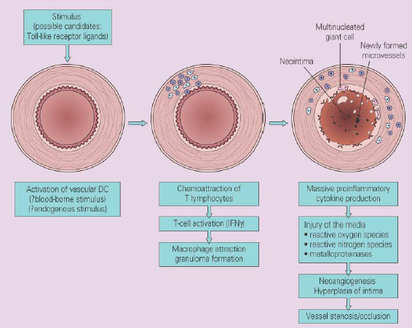
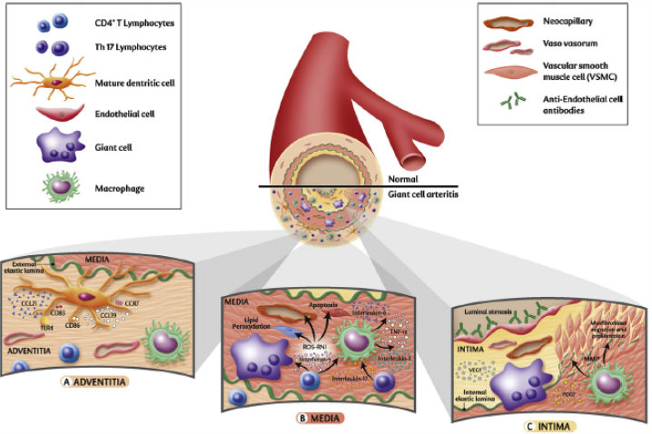
  - Appears to be two linked processes occurring in Giant Cell arteritis
    - Dendritic cells are releasing IL-1 beta, IL-6, IL-23 -> Th17 cells -> Release of IL-17 -> acute phase response
    - Dendritic cells release IL-12, IL-18 -> Th1 cells -> IFN-y -> vascular wall damage
    - Often when you treat GCA – treat acute phase response but continue to have grumbling vessel wall inflammation
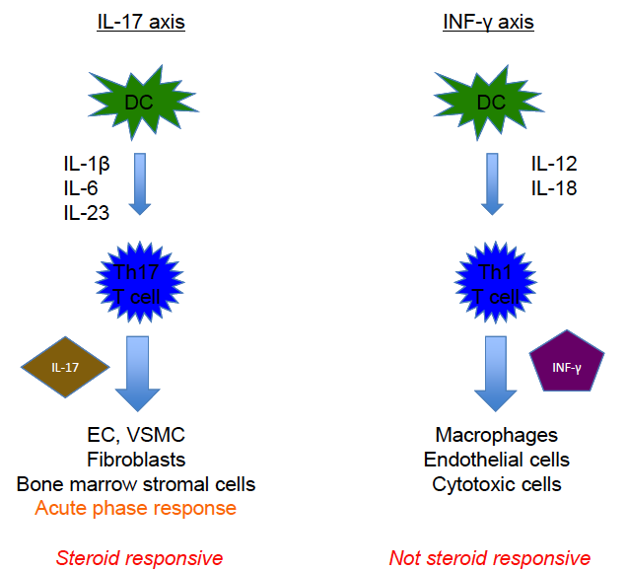
- Presentation
  - Mean age onset 708 year
  - Dramatic or insidious onset
  - Account for 15% of patients > 65 eyars with PUO
  - Occult malignancy can mimic symptoms – if poor response to steroid or general deterioration look for malignancy
- Clinical features
  - Manifestations of vascular injury/insufficiency
    - Clinical features relate to affected arteries
    - Headache
      - Most common symptom (> 67% patients)
      - Begins early – often presenting symptom
      - Severe, usually localized to the temple
        - May be occipital or less defined
        - May be precipitated by brushing hair
        - Can subside even when disease is still active (can’t be used to guide treatment decisions)
    - Jaw claudication – relatively specific for GCA
    - CNS ischaemic, TIAs or stroke – stenotic lesions in vertebral or basilar arteries
    - Scalp tenderness – particularly around temporal and occipital arteries
    - Tongue claudicaiton
    - Sore throat or painful swallowing
    - Peripheral neuropathies
    - Arteries can be thickened, tender and nodular, with reduced or absent pulsation
      - Second picture: progression to scalp necrosis
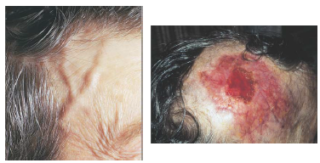
    - Visual disturbances in 25-50%
      - Incidence of visual loss 10-15%
        - Usually sudden, painless and permanent
        - Usually ant/post ischaemic optic neuropaty
      - Other
        - Amaurosis fugax
        - Retinal ischaemia
        - Diplopia
    - Involvement of other arteries
      - Aorta and major branches in 25% (CTA, MRA, PET)
      - Coronaries (MI, AR, CCF)
      - Clinical evidenc eof large artery involvement
        - Bruits/tenderness over arteries
        - Limb claudication/ischaemia
        - Absent/asymmetrical pulses
        - Aortic dissection and rupture – often a late complication
          - Because of proposed ineffectiveness of steroids in vascular wall inflammation
  - Manifestations of systemic inflammation
    - Polymyalgia rheumatica
      - Stiffness and pain in muscles of shoulders, pelvic girdle and neck; rarely torso
    - Constitutional symptoms
      - Anorexia, weight loss, fever, malaise, night sweats, depression, fatigue
    - Peripheral synovitis: mostly wrists
- Predictive value of clinical signs and symptoms in suspected GCA
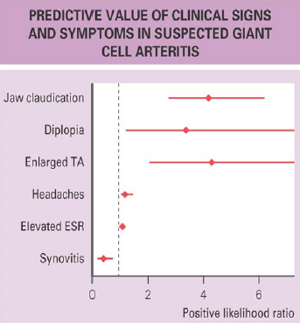
- Investigations
  - Bloods:
    - ESR
      - Usually elevated (useful to monitor Rx)
      - Can be normal
    - CRP and IL-6
      - Usually elevated
    - Anaemia (normochromic or hypochromic)
    - Thrombocytosis
    - EPG: non-specific increase in some globulins
    - Thyroid abnormalities
      - Associated with thyrotoxicosis – generally follows hyperthyroidism, sometimes hypothyroidism
    - Liver abnormalities
      - Abnormal LFTs common (ALP and GGT)
    - Anti-cardiolipin antibody in some
  - Temporal artery biopsy
    - High false negative rate
      - 1/3 of patients with clinical signs and symptoms
      - Higher likelihood with longer therapy with steroid
      - Can have non-specific changes especially after therpay
    - Need 2cm length
    - Value of having positive histology for later on when makng treatment decisions
    - Occasional involvement of TA in other vasculitides, especially polyarteritis nodosa (PAN)
  - Histopathology
    - Involvement
      - Muscular arteries with well developed elastic laminae and vas vasorum
        - Superficial temporal, vertebral, ophthalmic and posterior ciliary arties
        - Less severe involvement in carotids and central retina arteries
      - Intracranial vessels seldom involved
    - Panarteritis – lymphocytes (CD4+ T cells), histiocytes and plasma cells
    - Giant cell granulomas (not always seen)
    - Disruption of internal elastic lamina – important finding
      - Can also be caused by aging or atheroma
      - Will be visible long term regardless of previous steroid treatment
    - Patchy and skip lesions
    - Vessels can be thrombosed or stenosed with inflammatory vessel wall thickening
  - Colour doppler ultrasound of cranial arteries
    - Non-invasive assessment of the superficial arteries (bilateral temporal and occipital arteries)
    - Looking for hypoechoic wall thickening (halo) cause by oedema (sensitivity 75%, specificity 75%)
    - Operator dependent
    - Does not replace biopsy
    - Useful in certain situations
      - As a guide for biopsy site
      - Unable to biopsy
      - Past negative biopsy with flare
  - High resolution MRI of superficial cranial arteries
    - Also non-invasive
    - More expensive, less widely available
    - Less operator dependent
    - Can assess extra-cranial involvement in same study
    - Sensitivity 69% and specificity 91%
    - Does not replace biopsy
  - Assessment of extra-cranial, large vessel involvement
    - CTA and MRA useful, however some changes are not reversible, so can’t be used to monitor inflammatory burden or disease activity
    - Angiography
    - PET scanning
      - Can detect inflammation in extracranial large vessels
      - Not useful in evaluating temporal arteries (too small and high activity in nearby brain)
      - PET-CT ?useful in monitoring inflammatory burden – no data
- ACR 1990 Classification Criteria for GCA (3 of 5)
  - Used to differentiate between GCA and other forms of vasculitis (not from other differential diagnoses)
  - Age at disease onset ≥ 50 years
  - Headache of new onset or new type
  - Tenderness or reduced pulsation of TA
  - Elevated ESR ≥ 50mm/hr
  - Histological chanes of arteritis (either granulomatous lesions, usually with multinucleated giant cells, or diffuse mononuclear cell infiltration)
- Management
  - Steroid
    - Mainstay of therapy
    - Rapid response
    - Reduction in complication including blindness
    - Preferably given after biopsy but commence if strong clinical suspicion (classic clinical symptoms) or visual symptoms even if biopsy is delayed
    - Use even if biopsy is negative if strong clinical suspicion
    - Blindness can occur at any time before treatment
    - Pulse IV methylprednisone or high dose oral if visual symptoms
    - Less if no visual symptoms (1mg.kg of prednisone)
    - Slow taper once symptoms controlled (1 month)
    - Gradual reductions at lower doses (when < 10mg/day then taper 1mg/month)
    - Rapid reduction/withdrawal can lead to relapse
    - Usually on steroid for 2 years
    - Watch for relapse at low steroid doses or after cessation
    - May need steroid sparing agents (e.g. methotrexate)
    - Remember bone and other steroid complications including Pneumocystis jirovecii pneumonia prophylaxis
  - Consider aspirin and PPI
    - Only retrospective data for aspirin
  - Possible use of toxilizumab (anti IL-6 receptor antibody) – case series only so far
  - Good prognosis with many patients off treatment for 5 years
  - Monitor CXR (thoracic aortic aneurysm) and inflammatory markers every 2 years
- Summary
  - Most common vasculitis in people over age of 50
  - Clinical features relate to vascular injury and systemic inflammation
  - Obtain histological confirmation in all patients possible but should not delay starting treatment
  - Extremely sensitive to corticosteroid
  - Closely linked to PMR

Polymyalgia Rheumatica
- Clinical syndrome of aching pain and stiffness of the neck, shoulder and pelvic girdles
  - Rare in patients < 50 years (mean onset 70 years)
  - F > M
  - Dramatic or insidious onset
  - Associated with HLA class II genes
  - Varies with geographic regions
- GCA and PMR
  - Occur in the same patient population, in people of 50 years or older
  - Can occur separately, or together in the same patient
    - At same time
    - At different times
  - PMR 3-10 x more common than GCA
  - Manifesations of the same disease
  - No Th1 cells driving the immune response
    - No IFNy – less vessel wall inflammation
  - 40-60% GCA patients have PMR
  - In patients with PMR and no arteritic symptoms
    - 10-20% have temporal arteritic changes on biopsy
    - 30% have vascular FDG uptake on PET scan
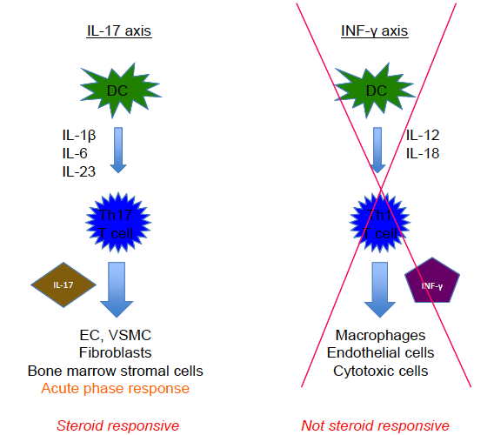

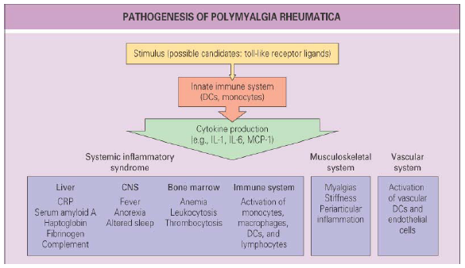
- Clinical features of PMR
  - Musculoskeletal symptoms
    - Pain and stiffness
    - Shoulder region and neck -> shoulder and pelvic girdles -> proximal muscles
    - Usually bilatereal and symmetric
    - Stiffness particularly severe after rest and in mornings
    - Pain worse with movement and night/early AM
    - Muscle strength normal but difficult to test because of main and stiffness
    - Tenderness
    - Later -> muscle atrophy (because not using)
  - Tenosynovitis and synovitis
    - Tenosynovitis/bursitis of shoulder, hip
      - ?Responsible for pain and stiffness
    - Mild inflammatory synovitis and effusions
      - Knee, wrists and more proximal joints including sternoclavicular joints
    - Carpal tunnel syndrome
    - Distal pitting oedema (extensive underlying tenosynovitis)
  - Constitutional symptoms
    - Occur in about 40% of patients
    - Low grade fever
    - Fatigue
    - Anorexia
    - Weight loss
    - Malaise
    - Depression
- Mimics
  - Can have PMR-type symptoms at onset of RA in elderly
    - 20% of patients presenting with PMR type symptoms will have developed RA after 1 year
  - Myositis
    - In myositis weakness limits function
    - In PMR pain limits function
  - Paraneoplastic myalgias
  - Connective tissue diseases
- Investigations in PMR
  - Raised ESR and IL-6
  - Anaemia
  - Increased immunoglobulins
  - Abnormal LFTs (ALP and GGT)
    - Non specific inflammation on biopsy
  - Normal muscle enzymes/normal EMG/some atrophy, no inflammation on biopsy
  - Non-specific inflammatory synovial fluid
  - Imaging
    - Ultrasound or MRI
      - Subacromial, subdeltoid, trochanteric and cervical bursitis
      - Tenosynovitis of long biceps head
      - Glenohumeral or hip synovitis
    - FDG/PET
      - Interspinous bursitis, widespread enthesopathy, synovitis +/- background med or large vessel vasculitis
    - Beware peripheral synovitis (fingers, toes) – suggests an alternative diagnosis e.g. RA or inflammatory OA
  - Rule out giant cell arteritis
    - When in doubt, biopsy!
    - Findings of GCA (biopsy or imaging) override PMR diagnosis
    - Sometimes can see small vessel vasculitis surrounding an uninflamed temporal artery – significance unclear
- Provisional ACR-EULAR 2012 classification criteria for PMR
  - Mandatory
    - Age ≥ 50
    - Aching in both shoulders
    - Abnormal CRP and/or ESR
  - Additional (≥ 4 points without US or ≥ 5 points with US
    - Morning stiffness > 45 minutes (2 points)
    - Hip pain or decreased ROM (1 point)
    - Negative RF or CCP Ab (2 point)
    - No peripheral synovitis (1 point
    - Ultrasound findings in shoulders/hips (1-2 points)
- Management of PMR
  - Steroid
    - Mainstay of treatment
    - Rapid response
      - If no rapid response – consider alternative diagnosis including paraneoplastic phenomenon
    - Dose depends on if there is co-existing GCA
      - If not, then 15-20mg of p
    - Gradual reduction once symptoms controlled
    - Need very slow wean at lower doses
    - Average time of treatment is 2 years
  - Watch for relapse at low steroid doses or after cessation
    - May need to consider steroid sparing agents (e.g. methotrexate)
    - Consider aspirin and PPI
    - Watch for development of vasculitis
      - Can occur later down the track
    - Remember bones and other steroid complications
    - ?Future role for blockade of IL-6R
    - Good prognosis with many patients off treatment by 5 years
- Summary
  - Syndrome of muscular pain, stiffness and constitutional symptoms in patients over 50 years
  - Can mimic other conditions
  - Closely linked to giant cell arteritis
  - Extremely sensitive to corticosteroid

Fibromyalgia
- Syndrome of chronic, widespread muscloskeletal pain and tenderness
  - ‘Centralised pain syndrome’ or ‘central sensitivity syndrome’
- 2-4% population, 10% of population reports chronic pain
- Occurs more in women than men
- Occurs alone or with other chronic disease
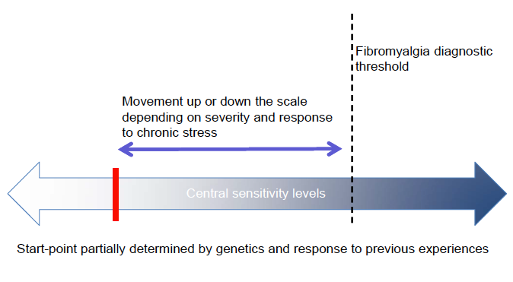
- Clinical features of fibromyalgia
  - ≥ 3 months chronic widespread bodily pain
  - Other variable (central sensitivity symptoms)
    - Fatigue
    - Stiffness
    - Unrefreshing sleep: distruption of stage 4 nREM sleep
    - Cognitive disturbances: memory and attention
    - Emotional distress
    - Paraesthesia/dysaesthesiae
    - Autonomic dysfunction
- Associated conditions
  - Depression
  - Anxiety
  - Headache
  - Irritable bowel
  - Irritable bladder
  - Interstitial cystitis
  - TMJ disorder
  - Chronic sinus pain
  - Multiple chemical sensitivities
  - Pelvic pain
  - Vulvodynia
  - Restless legs syndrome
- Every patient has a different and fluctuating clinical spectrum: chronic, fluctuating disease course but not dangerous and can improve
- Physical examination
  - Exclude other causes of chronic pain
  - Widespread musculoskeletal tenderness
    - Tender points
      - 11 out of 18 for research purposes only (not commonly used in clinical practice)
      - Heavily influence by current distress levels
- Diagnosis
  - 2010/2011 ACR diagnostic criteria
    - Chronic widespread musculoskelatal pain – measured by the widespread pain index (WPI)
    - Central sensitivity symptoms – measured by the symptom severity score
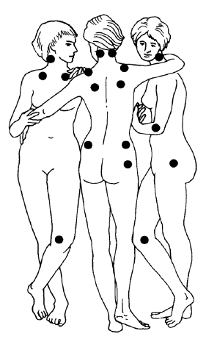
- Why does fibromyalgia develop?
  - Genetically susceptible
    - Aggregates alone/with depression in some families
    - Increased prevalence of specific neurotransmitter genotypes in some patients
  - Trigger stressor physical/psychological
    - Illness (acute or chronic)
    - Trauma (mental and physical)
    - Psychological stress
    - None
- Pathophysiology of fibromyalgia: central sensory desensisation
  - Afferent activity from fast (Aδ) and slow(c) fibres form peripheral mechano and nocepceptors to dorsal horn
  - Normal descending inhibitory tone from brainstem to dorsal horn modulates afferent sensory information – reduced in fibromyalgia due to central 5HT and noradrenaline dysfunction
  - -> Increased sensitivity of nociceptive-specific neurons and wide dynamic range neurons in the dorsal horn
  - Transmission of usually non-painful sensation e.g. movement or light touch, via pain pathways in the spinothalamic tract (nociceptive specific neurons and wide dynamic range neurons are stimulated by signals that are not nociceptive in nature)
  - Results in allodynia where painful stimuli are experienced as painful
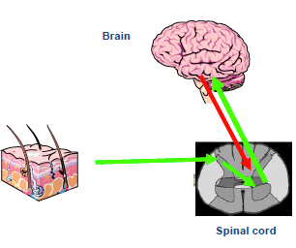
  - Amplicfication in pain processing
    - Pain pathway signals transmitted via the thalamus to the somatosensory cortex where they are influence by emotional and cognitive centres
  - Amplified sensations in FM
    - Pain
    - Dysaesthesia/paraesthesia
    - Tinnitus
    - Bowel and bladder sensations (e.g. amplified sensation of peristalsis in IBS)
    - Dizziness and palpitations
    - Noise/light/odours
    - Sensitivities to chemicals
    - Side effects with drugs
- Imaging
  - Further abnormalities in pain processing seen using brain nociceptor-event related potentials, fMRI and SPECT
    - Amplification
    - Spread of cerebral activation
    - More widespread brain region activation
    - Greater intrinsic connectivity between multiple brain networs associated with pain perception and cognition
- Biochemical and neuroendocrine abnormalities (not used in clinical practice)
  - Reduced levels of 5HT and NA which are important in central and peripheral pain processing (synaptically inhibit release of pain neurotransmitters)
  - Elevated substance P in CSF
  - Neurotransmitters glycine and taurine, and metabolite levels of glutamate and aspartate correlate to pain intensity measures in FM
- HPA axis dysfunction
  - Elevated basal levels of ACTH and FSH
  - Reduced levels of IGF-1, fT3, GH, oestrogen and urinary cortisol
  - Distupted circadian rhythm of serum cortisl (abnormally high levels in eventings)
  - Abnormal hypersecretion of ACTH but poor cortisol response to stress
  - Reduced autonomic function
    - Links with central mechanisms in FM, related to levels of 5-HT and may contribute to non pain clinical features (e.g. fatigue, sleep disturbance)
- Not damaging or degenerative but high burden
  - Significantly diminished personal health
    - Self-related QOL lower than with RA, renal dialysis and many other chronic diseases
  - Wide ranging downstream societal costs
    - Health care costs
    - Absenteeism/underemployment/unemployment
    - Disability/sickness benefits
    - Family and social network burdens
- Co-existent with other chronic illness
  - 41% RA patients and 22% of CCF patients meet FM criteria (associated with worse health outcomes)
  - 22% SLE patients
- Management
  - Variable results even from proven therapies
    - Psychosocial factors
    - Compliance
    - Tolerance
  - At least moderate reduction in pain levels result sin improvement in sleep, depression, anxiety, function, QOL, ability to work
  - Needs to be multidisclipinary
  - Education
    - Diagnosis
    - Mechanisms
    - Dimensions
    - Management principles
    - Outcome
    - Patient understanding -> proactive, regain sense of control -> accept responsibility -> begin to self-manage
  - Exercise
    - Proven benefits with graded, aerobic exercise
    - Walking, warm pool
    - Start low and slow
    - Build to 20 minutes 3 x per week
  - CBT
    - Proven benefit, best with tailored program
    - Helps patients live with the pain
    - Relaxation, pacing, goal setting, coping strategies
  - Other non-pharmacological
    - Massage
    - Acupuncture
    - Myotherapy
    - Tai chi etc.
  - Address social issues
    - Relationships, home, work, economic problems, compensation/disability claims
  - Drugs
    - Aim to target specific mechanisms and symptoms
    - Start with low doses and gradually build
    - At best, partial responses, not all patients
    - Remember to treat associated conditions e.g. depression, anxiety
    - Analgesics
      - Paracetamol
      - Tramadol or tapntadol (likely via noradrenaline re-uptake inhibition)
      - NSAIDs – sometimes
        - No intrinsice inflammation
        - May help if underlying inflammatory condition e.g. RA that is driving fibromyalgia
      - Opioids do not help
    - Serotonin and noradrenaline modulators (facilitate DNIC)
      - TCAs (amityptyline) reduce pain, fatigue and improve sleep, overall well being (low dose e.g. 5-10mg)
      - Balance (dual) 5-HT and NA reuptake inhibitor
        - Milnacipran – only drug with Australian TGA approval for use of FM (but not currently available)
          - Helps pain, fatigue and global measures
        - Duloxetine
          - Improves pain, fatigue and function
      - SNRIs (venlafaxine) may help pain
      - Some evidence for use of esreboxetine (NRI)
    - Membrane stabilizers
      - A-2-δ ligands (pregabalin, gabapentin) improve pain, sleep, fatigue and general well-being
    - Drugs not available in Australia
      - SNRI: milnacipran
      - Muscle relaxants: cyclobenzaprine (similar to a TCA)
      - For sleep: sodium oxybate, ropinirole
    - Trial therapies
      - Repetitive transcranial magnetic stimulation (RTMS)
        - Overseas pilot data looks promising
      - Naltrexone
        - Used in low doses in small trials with some evidence of benefit
        - Possibly helps because of hyperactivity in the endogenous opioid system in fibromyalgia
- Summary
  - Common, debilitating condition
  - Widespread bodily pain and tenderness
  - Central sensitization of pain transmission neurons in the dorslal horn -> amplification of pain processing -> lowered pain threshold or allodynia
  - Multidisciplinary management for best outcome

Spondyloarthropathies and Psoriatic Arthritis

Spondyloarthritis
- Formerly ‘seronegative spondylarthropathy;
- Share several clinical features
- Can be differentiated according to
  - Axial spondyloarthropathies – predominantly affecting the axial skeleton – spine and sacroiliac joints
  - Peripheral spondyloathropathies – predominantly affecting peripheral joints
  - Extra-articular disease
- Acute anterior uvetitis occurs in about 40% of patients with spondyloarthritis
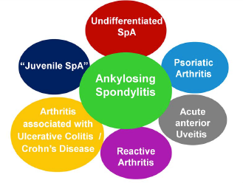

Features of Spondyloarthritis
- Inflammatory back pain
- Arthritis –oligo-articular (<5 joints), lower limb
- Sacro-ilitis
- Enthesitis
- Dactylitis
- Uveitis
- Psoriasis
- HLA B27 positivity
- Family history
- Inflammatory bowel disease
- Recent infection: genitourinary or gastro-intestinal

Inflammatory Back Pain
- Chronic, > 3 months
- Differentiate SpA as cause from other causes
- 4/5 of following gives good sensitivity/specificity
  - Onset before the age of 40
  - Insidious onset
  - improvement with exercise
  - No improvement with rest
  - Nocturnal pain that improves on walking
  - (Responds to NSAIDs)

Ankylosing Spondylitis and Axial Spondyloarthritis
- Axial spondyloarthropathies: inflammatory back pain that does not fulfil the criteria for ankylosing spondylitis
- Ankylosing spondylitis
  - The most common and ‘classical’ form of SpA
  - Inflammatory arthritis of the axial skeleton
  - Extra-axial and extra-articular involvement
  - Progressive stiffening and fusion of the spine
  - Strong association with the HLA B27 gene
  - Epidemiology
    - 0.5-1% of the population
    - M:F 3:1
    - Main determinant: frequency of HLA B27 in the population
      - 5% of B27+ population
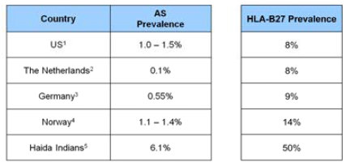
  - Delay in diagnosis is common: approximately 9 years after onset of symptoms
  - Age in onset is 15-40 years
  - Pathogenesis
    - Strongly genetically influence
    - HLA B27 is the gene with strongest association
      - HLA B allele of MHC class I molecule
      - Antigen presentation to cytotoxic CD8+ T cells
      - Several theories for mechanism behind this
      - Confers 50% of the risk for ankylosing spondylitis (need something else for disease)
    - New bone formation
      - New bone formation is characteristic
        - Sacro-iliac joints, vertebra (syndesmophytes)
        - Eventually leads to ankylosis
      - Enthesis is a primary source of pathology
        - Insertion of tendons/ligaments onto bone
        - Annulus fibrosis in the spine
        - May interact with innate immune system to trigger disease (animal models)
      - Enthesitis leads to bone destruction/erosion
      - Subsequently, new bone formation
  - Clinical features
    - Axial features
      - Inflammatory back pain
      - Buttock pain – often alternating, poorly localized (sacro-ilitis)
      - Restriction in spinal movement
        - Characteristic posture
        - All segments of spine have reduce movement
        - Chest expansion reduced (costo-vertebral joints)
    - Final stage of AS with severe kyphosis of thoracic and cervical spine
      - Straightening of cervical lordosis
      - Exaggeration of thoracic kyphosis
      - Straightening of lumbar lordosis
      - Hip involvement as well in this patient: Fixed flexion deformity of both hips
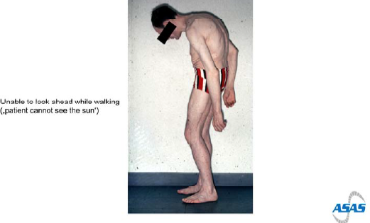
    - Extra-axial involvement
      - Hip arthritis – most common ‘peripheral’ joint
        - Groin/thigh pain (can radiate to knee)
        - 30%
      - Peripheral arthritis/synovitis
        - Mono or oligo-articular
      - Enthesitis – especially Achilles, plantar fascia, chest wall, pelvic brim
        - Of Achilles tendon
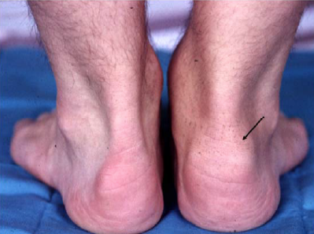
      - Dactylitis/sausage digit
    - Extra-articular involvement
      - Acute uveitis in 25-40%
        - Painful red eye, photophobia, blurred vision
        - Recurrence can be a problem
        - Can get recurrent acute anterior uveitis as an HLA-B27 associated disease without ankylosing spondylitis
      - Inflammatory bowel disease
        - 70% of asymptomatic patients with ankylosing spondylitis who have a colonoscopy have subclinical colitis
        - 6-7% have true inflammatory bowel disease
      - Osteopenia
      - Neurological: cauda equina, fracture, A-a subluxation
      - Cardiac: CVD risk, aortic regurgitation, conduction disturbance
        - Atherosclerotic disease related to inflammatory process (most common cardiovascular complication of AS)
      - Respiratory: chest wall restriction, apical fibrosis (apical fibrosis is usually asymptomatic, chest wall restriction is more common cause of symptoms)
      - Secondary amylodosis
  - Investigations
    - Blood tests
      - HLA B27 (NOT a diagnostic test)
        - Increases likelihood of someone having AS if they have inflammatory back pain
        - Present in 8-9% of people with Northern European ancestry
        - Positive in > 90% of patients with AS
      - Inflammatory markers (normal in up to 25%)
    - Imaging
      - Sacro-iliac joints
        - If present, significantly increases the likelihood of spondyloarthritis
        - Early cahanges: erosions, sclerosis at joint margins
        - Later: pseudo-widening of joint (combination of erosions)
        - Last: joint space narrowing progressing to ankylosis
      - Grading of sacoilitis
        - Grade 0: Normal
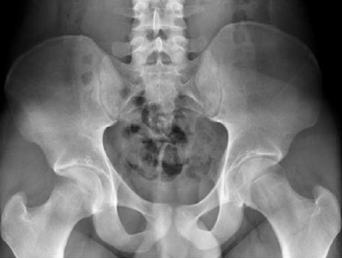
        - Grade 2 on right and grade 3 on left
          - Right: sclerosis along joint margin and some narrowing
          - Left: obliteration of joint in one area (partial ankylosing) and moving further up sclerosis and joint space narrowing
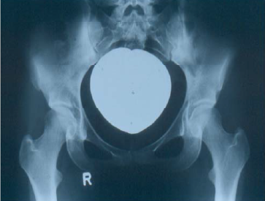
        - Grade 4: ankylosis of SI joint – no visible joint line
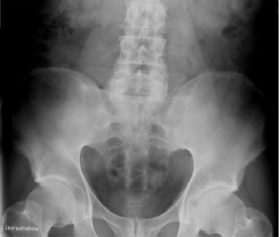
      - Cervical and thorac-lumbar spine
        - Annulus fibrosis is probable site of initiation of radiographic changes
        - Vertebral squaring: due to erosion at corners of the vertebral bodies (where annulus fibrosis attaches) -> this can develop into a Romanus lesion with sclerosis of the bone (compare to one above)
        - Differentiate syndesmophyte vs osteophyte
          - Osteophyte initiates growth in horizontal plane
          - Syndesmophyte initiates growth in the vertical plane
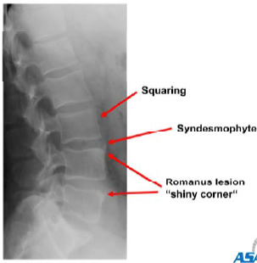
        - With fusion of the spine can develop atypical fractures as spine behaves like a long bone
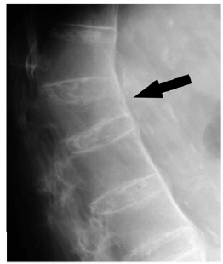
  - Diagnosis – modified New York Criteria
    - Clinical – at least one of
      - Inflammatory low back pain and stiffness > 3/12
      - Restriction in lumbar forward or lateral flexion
      - Restriction in chest wall expansion
    - Radiology – at least one of
      - Bilateral grade 2 sacro-ilitis on X-ray
      - Unilateral grade 3-4 sacro-iliitis on xray
    - Need at least one of each category for AS diagnosis
  - The problem
    - Radiographic sacro-ilitis takes years to develop
    - In the absence of sacro-ilitis, the diagnosis of ankylosing spondylitis cannot be made
    - Introducing the concept of ‘pre-radiographic AS’ or ‘axial spondyloarthritis’
- Axial spondyloarthritis
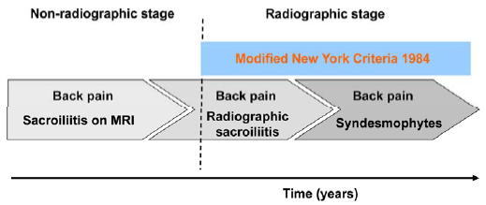
- MRI in spondyloarthritis
  - MRI can be performed of SIJs and/or spine
  - Features of sacro-ilitis on MRI
    - Bone marrow oedema (active inflammation)
    - Erosions detected earlier
    - Synovitis, enthesitis
  - Features of spinal involvement similar to radiographs
    - Bone marrow oedema at vertebral corners
    - Erosions, spondylodiscitis etc.
  - Definition of positive MRI-SI joint (Coronal STIR image, water = white)
    - Subchondral bone marrow oedema – acute (bilateral) sacroilitis
- Axial spondyloarthritis
  - ASA classification for axial SpA (in patients with back pain > 3 months and age at onset < 45 years)
  - Have broadened definition of axial spondyloarthritis – don’t even have to have sacroilitis, much more dependent on HLA-B27
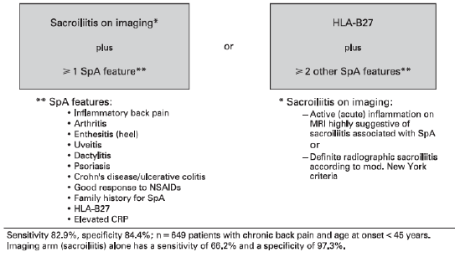
- ASAS/EULAR Recommendations for management of ankylosing spondylitis
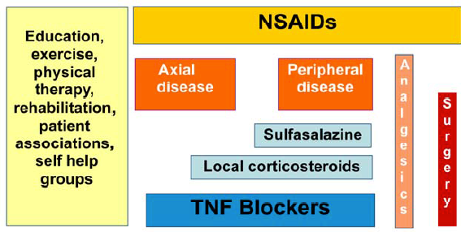
  - Physiotherapy/exercise program and NSAID
    - May be effective in preventing radiographic progression
      - Less radiographic progression with continuous vs. on demand use of NSAIDs
    - Risk of NSAID therapy
  - Axial disease
    - After NSAID/Exercise -> next step is TNF blockers (no evidence for other disease modifying drugs)
    - Local corticosteroids can be useful for sacro-iliac disease or troublesome facet disease
  - Peripheral disease
    - Sulfasalazine for peripheral arthritis (but no evidence for other disease modifying agents)
    - Local corticosteroids can be useful
    - TNF inhibitors (infliximab/etanercept/adalimumab): 70-90% get improvement in symptoms
  - TNF inhibitors
    - Previously thought that despite being fantastic for symptoms did not affect radiographic progression
    - Recent prospective longitudinal study in 330 patients found
      - TNF inhibitor use was associated with less radiographic progression
      - Early initiation and longer duration of tratment seemed more protective
      - Smoking independently predicts radiographic progression
      - More data required
    - Possible window of therapeutic opportunity in early disease
- Treatment of ankylosing spondylitis
  - Etanercept does not work in IBD!
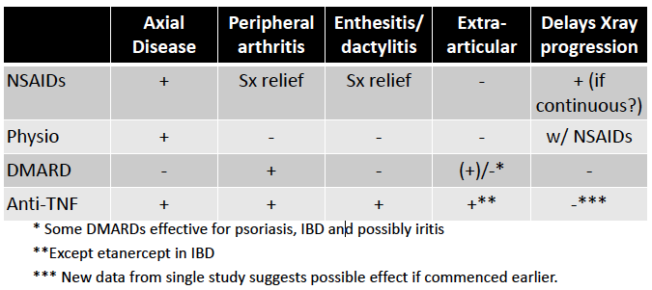

Psoriatic Arthritis
- Epidemiology
  - 3% of population have psoriasis
  - 15% of psoriasis patients develop
  - Men and women affected equally
  - Mostly psoriasis precedes arthritis
    - 15-20% arthritis precedes skin disease
    - 15-20% simultaneous onset
- Pathogenesis
  - Genetic
    - 40% have first degree relative with either psoriasis or PsA. Polygenic
    - Not as strongly linked with HLA b27 as other SpA
  - Tissue specific factors
    - Role of the synovio-entheseal complex
    - Possible role of trauma
      - Psoriasis and trauma are closely linked
      - Koebner phenomenon: patients with psoriasis who have surgery or trauma at a site triggers psoriasis at that site
      - ‘Deep koebner’ phenomenon hypothesized to trigger psoriatic arthritis. Patients with psoriatic arthritis tend to develop arthritis at the joints peripherally injured
      - Nail psoriasis tends to more frequently affected the thumb nail of the dominant hand
  - Not fully understood
- Clinical features
  - Five distinct patterns of joint involvement
    - Asymmetric oligoarthritis/monoarthritis
    - Polyarthritis – symmetric
    - Spondylo-arthritis – axial, AS like
    - Distal interphalangeal joint with nail disease
    - Arthritis mutilans
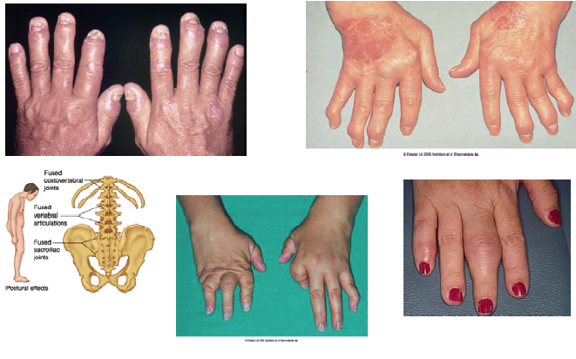
- Psoriatic arthritis: affects hands in rays not rows c.f. RA which tends to affect joints in rows
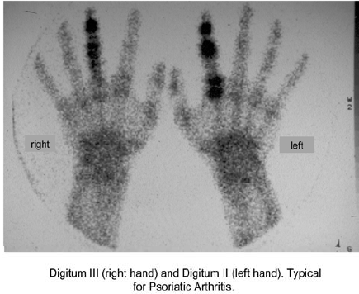
- Clinical features
  - Dactylitis – ‘sausage digit’
    - Tendon and joint inflammation
    - Swelling along length of digit
  - Enthesitis
  - Nail changes more common
    - Pitting, onycholysis, nail plate crumbling
    - Correlates better with psoriatic arthritis than skin disease
- Investigations
  - Blood tests
    - Acute phase response
    - Typically RF and CCP negative (small % positive)
  - Imaging
    - Erosions with new bone formation
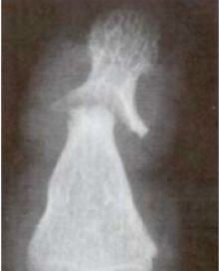
    - Can get ankylosis
    - Check for sacro-ilitis
- Diagnosis: CAPSAR criteria
  - Presence of musculo-skeletal inflammation (peripheral arthritis, enthesitis and axial) plus three points from
    - Present skin psoriasis (2 points)
    - Past or family history of psoriasis (1 point)
    - Dactylitis (1)
    - Nail changes – pitting, oncycholysis (1 point)
    - RF negative (1 point)
    - Juxta-articular new bone formation on xray (1 point)
- Treatment
  - Avoid systemic steroids because rapid wean of topical steroids can cause flare of skin disease
  - DMARDS (methotrexate, sulfasalazine and lefluoamide) used for peripheral disease
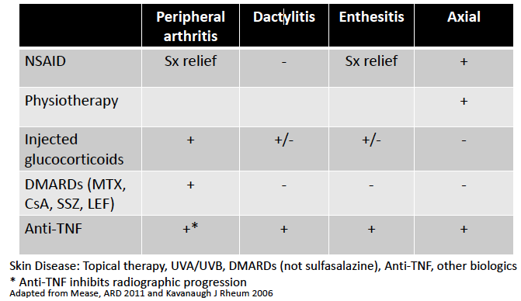
- Other management principles
  - More patients in a tight control, ‘treat to target’ regimen achieve minimal disease activity than patients receiving ‘usual care’
    - Rapid up titration of conventional then biologic DMARD
  - Impact of methotrexate co-prescription with TNF inhibitor remains unclear
    - In RA co-prescribe TNF inhibitors with methotrexate (appears to improve efficacy of TNF inhibitors
    - Doesn’t seem to be the same in psoriatic arthritis but may improve drug survival, not necessarily efficacy
  - Delayed diagnosis (including of only 6 months) lead to more radiographic progression

Reactive Arthritis
- A sterile arthritis following a remote infection
- Causative organisms
  - Genito-urinary infection: Chlamydia trachomatis
  - Gastro-intestinal infection: Shigella species, Salmonella species, Campylobacter, Yersinia
  - Others also involved – E. coli, C. pneumoniae
- Precieding infection – usually 1-4 weeks
- Arthritis
  - Asymmetric, oligoarticular, lower limb
  - Enthesitis
  - Sactylitis
  - Sacro-ilitis
- Classical triad – arthritis/urethritis/conjunctivitis – uncommon
- Extra-articular manifestations
  - Skin: keratoderma blenorrhagica (scaly rash over palms and soles), circinate balanitis (penis), mouth ulcers
  - Ocular: conjunctivitis, urethritis
  - Genito-urinary: aseptic urethritis, cervicitis, prostatitis
  - Constitutional symptoms including fevers – may mask as a septic arthritis
- Investigations
  - Assess inflammatory response – CRP, ESR, etc.
  - Identify preceding infection
    - Urinary PCR for C. trachomatis (1st pass urine)
    - Identifying previous GI infections more difficult
  - HLA B27 – more severe, chronic disease
    - Not helpful in diagnosis
  - Synovial fluid analysis
  - Imaging
  - Exclude other cause
- Treatment
  - If C. trachomatis – treat, contact tracing
  - NSAIDs – typically effective
  - Intra-articular glucocorticoids
  - Systemic glucocorticoids if unwell
  - DMARD – sulfasalazine for chronic disease
- Natural history
  - Median disease duration 3-5 months
  - Depends on pathogen, HLA B27 status
  - 15-20% persists for > 12 months
    - If HLA B27 positive may be trigger for chornic spondyloarthritis

IBD Aasociated Sponydyloarthritis
- Estimates vary, approximately 10-20% of IBD patients
- More common in those with
  - Other extra-intestinal features
  - Complications of bowel disease
  - Large bowel involvement (for Crohns)
- Two subtypes
  - Axial – asymptomatic sacro-ilitis in up to 20%
    - Same clinical presentation as AS
  - Peripheral
    - Usually acute, oligoarticular and lower limb
    - Deformities/erosions are rare
    - Can be self-limiting, related to flares of IBD
    - Rarely, progressive, independent of IBD activity
    - Can see other features of spondyloarthritis e.g. enthesitis
- IBD associated spondyloarthritis
  - NSAID – use with caution
  - DMARDS – sulfasalazine, joints and bowel
    - Not effective in axial disease (like in ankylosing spondylitis)
  - Contolling bowel disease often helps
    - Surgery in Crohns not usually helpful
  - Anti-TNF for joints and bowel (not etanercept!)
  - Axial disease treat as per AS

Undifferentiated Spondyloarthritis
- If a patient ahs features of spondyloarthritis without inflammatory back pain but no definable diagnosis, labeled as undifferentiated peripheral spondyloarthritis

